Lesson 07 Lesson-End Project
Containerizing Legacy Docker Application

Project Agenda: As a DevOps engineer, you are required to containerize the legacy application system using Docker.

Description: Your team has been asked to sync the Django application and the database so that the information can be stored and accessed again, on demand. This is a legacy application with two components: a Django application and a Postgres database. Now, your project manager asks you to containerize the legacy system using Docker. So, you are required to create Docker images for these components using the Dockerfile and connect them using the docker-compose file.

Tools required: Docker

Pre-requisites: You must have installed all the required tools and should have a working Docker setup in order to proceed. In case you do not have it please refer to Lesson 08 Demo 1 to install and setup Docker..

Expected Deliverables: The information processed through the application must be stored and accessed, on demand.

Note: This project requires a Dockerfile, a Python dependencies file, and a docker-compose.yml file
Steps to be followed:
- Create a new directory
- Create a Docker file
- Install the Python requirements defined in the req.txt file to modify the parent image.
- Create a .yml file in the project directory lep2 that defines the services that make the app
- Create the Django project
- List all the contents of the Django Project
- Change the ownership of new files as the current owner is root
- Set-up a Database connection
Step 1: Create a new directory
mkdir lep2
cd lep2
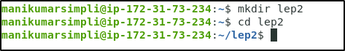
Step 2: Create a Dockerfile
nano Dockerfile
2.1 Add the following code to the Dockerfile so that it can start Python3 parent image:
FROM python:3
ENV PYTHONUNBUFFERED 1
RUN mkdir /code
WORKDIR /code
COPY req.txt /code/
RUN pip install -r req.txt
COPY . /code/
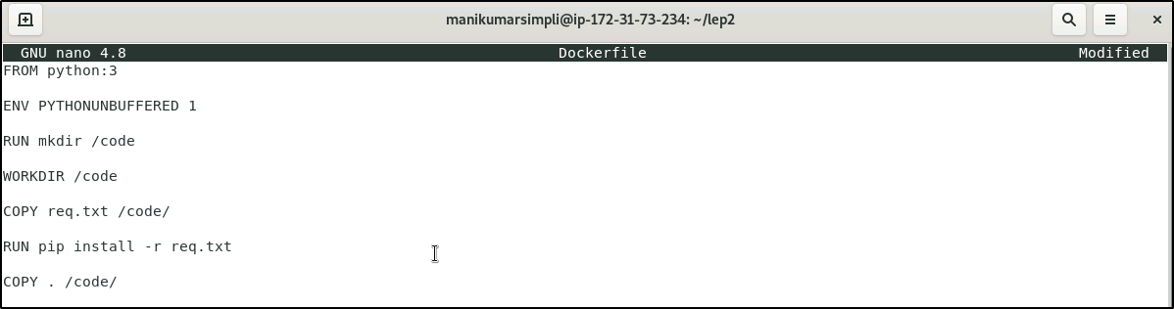
Note: Press Ctrl+X to exit the editor. Then type Y and press Enter to save the file.
Step 3: Install the Python requirements defined in the req.txt file to modify the parent image
3.1 Create a req.txt in your project directory lep2
nano req.txt
3.2 Add the following software in req.txt file:
Django>=2.0,<3.0
psycopg2>=2.7, <3.0
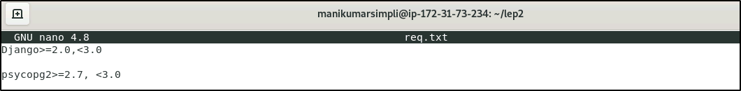
Note: Press Ctrl+X to exit the editor. Then type Y and press Enter to save the file.
Step 4: Create a .yml file in the project directory lep2 that defines the services that make the app
4.1 Create a docker-compose.yml file
nano docker-compose.yml
4.2 Add the following code to define the services:
version: '3.3'

services:
db:
image: postgres
web:
build: .
command: python manage.py runserver 0.0.0.0:8000
volumes:
- .:/code
ports:
- "8000:8000"
depends_on:
- db
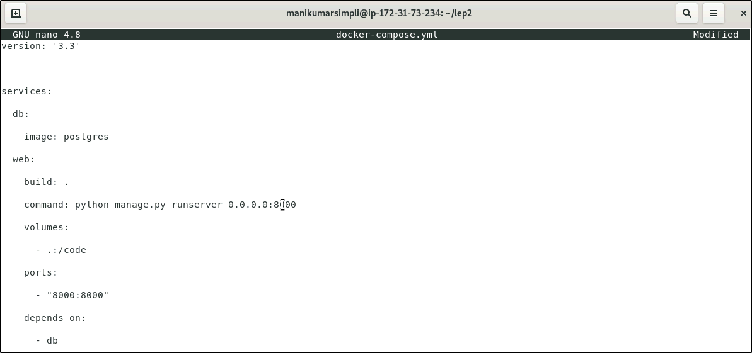
Note: Press Ctrl+X to exit the editor. Then type Y and press Enter to save the file.
Step 5: Use the following command to create the Django project:
sudo docker-compose run web django-admin startproject composeexample .

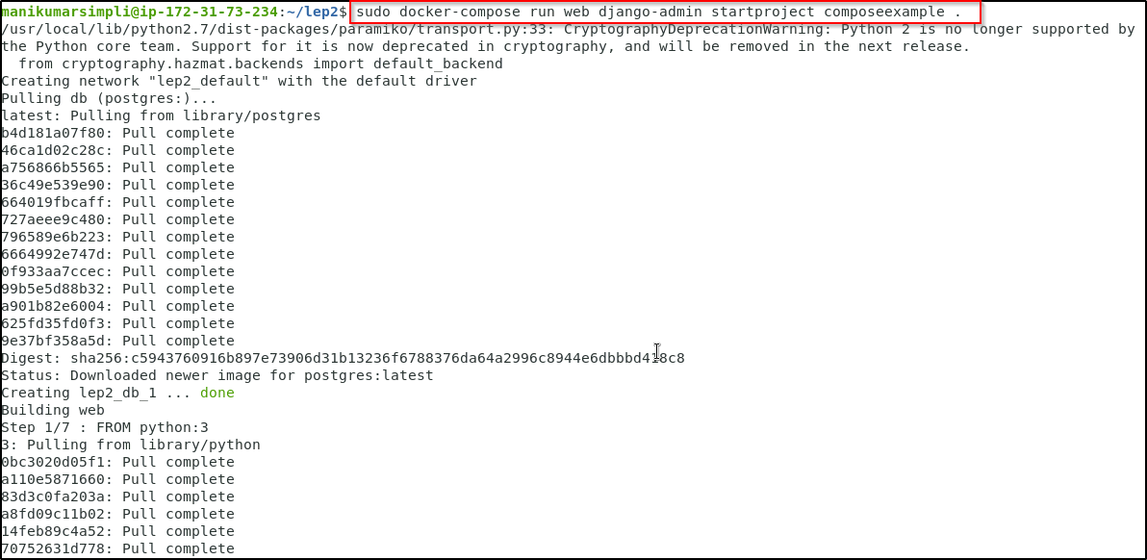

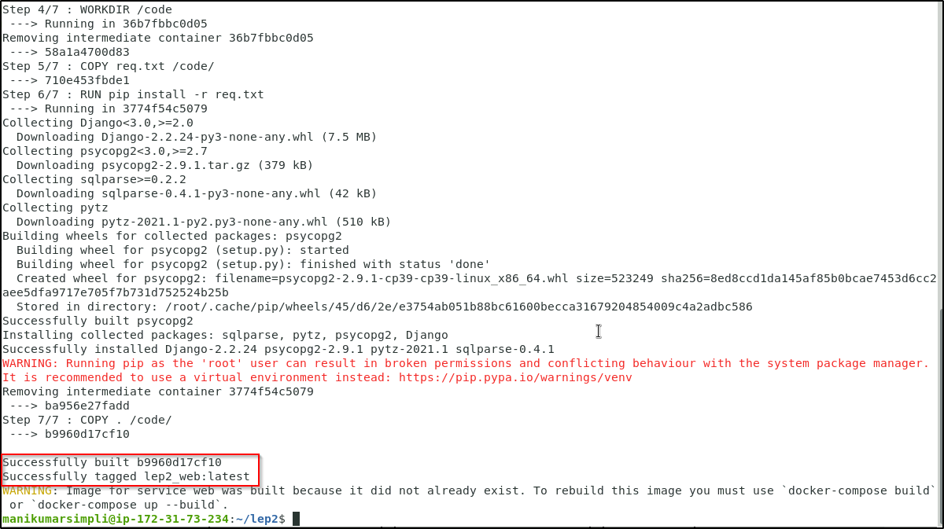
Step 6: List the contents of the Django project by using the following command:
ls -l
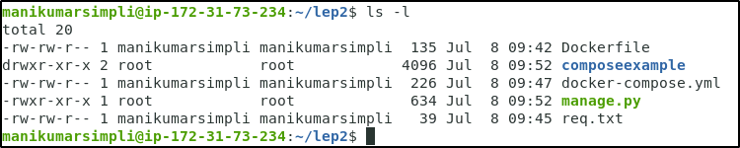
Step 7: Change the ownership of new files as the current owner is root:
sudo chown -R $USER:$USER .
Step 8: Set up a database connection for Django
8.1 Edit cmps_eg/settings.py file in the project directory:
edit composeexample.py
8.2 Press E to edit the composeexample.py file
8.3 Replace the DATABASES=…… commands with the following:
DATABASES = {
'default': {
'ENGINE': 'django.db.backends.postgresql',
'NAME': 'postgres',
'USER': 'postgres',
'HOST': 'db',
'PORT': 5432,
}
}
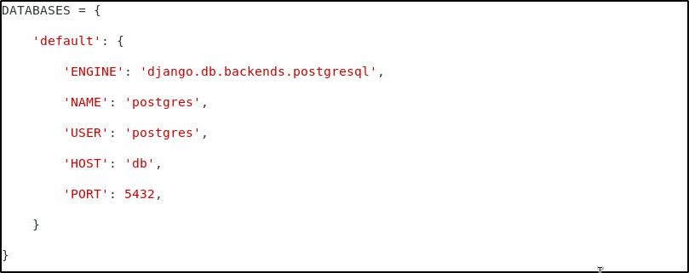
Note:Press ESC button and type :wq + Enter.
8.4 Run the following command to start the application:
sudo docker-compose up -d
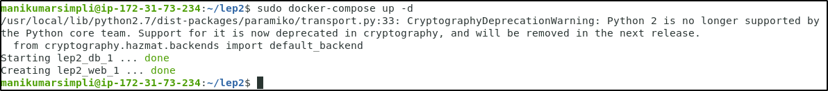
8.5 List the containers by using this command:
sudo docker-compose ps
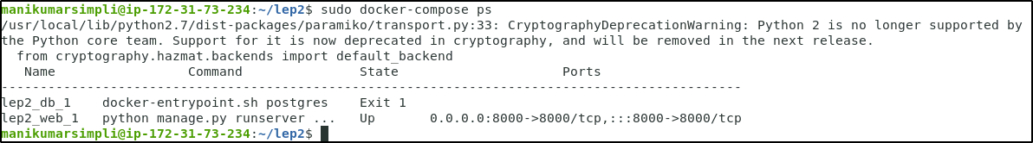
8.6 Use the following command to bring the application down:
sudo docker-compose down
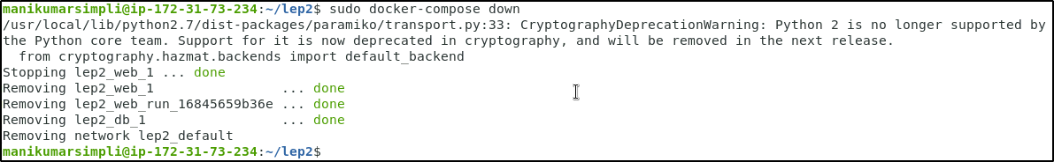
8.7 Remove the Django app by using the following command:
rm -rf django

